06 · MVC Pattern
Project: StaffSync — HRM System (backend)
Document type: Story · Status: To Do · Owner: Shiwani Jha

1. Description
The HRM backend application follows the Model-View-Controller (MVC) architectural pattern, a software design approach that separates an application into three interconnected layers. This separation provides modularity, easier maintenance and scalability.
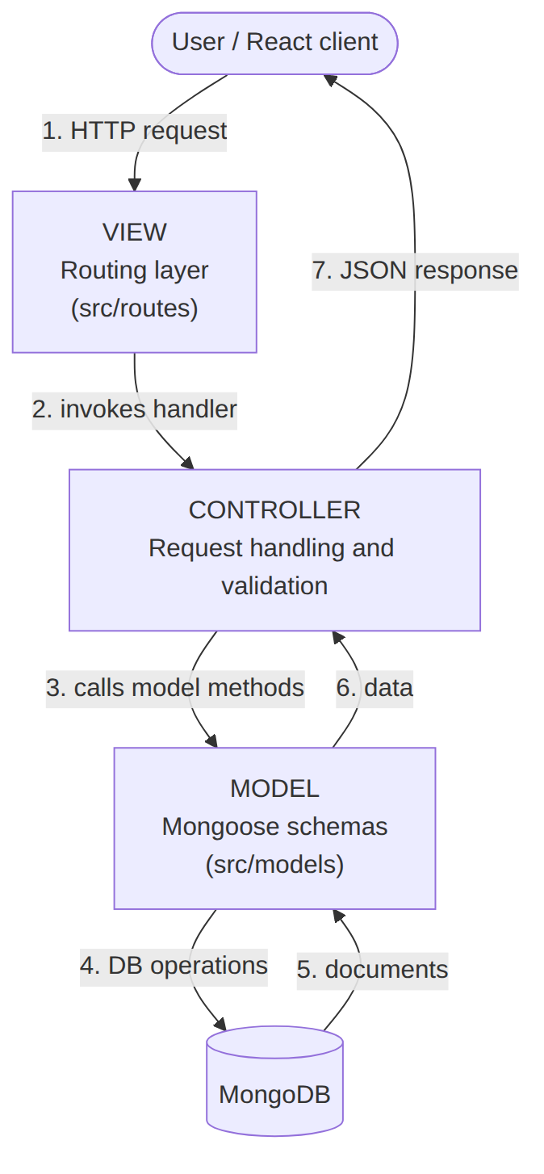

2. The Three Layers

2.1 Model Layer (Data Layer)
Responsible for all data-related logic: schema definitions, validation rules, indexes and the database operations performed through them. Implemented with Mongoose, a schema-based solution for modelling MongoDB data.
Model file | Collection | Highlights
User.js | users | unique email, role enum, hidden password, isActive
Attendance.js | attendances | unique index {employee, date}
Leave.js | leaves | status enum, reviewedBy reference
Announcement.js | announcements | audience enum, author reference
Training.js | trainings | durationHours min 1, createdBy reference

2.2 Controller Layer
Acts as the intermediary between the view (routes) and the model. It receives incoming requests, processes the input (validation or transformation), calls the appropriate model methods and returns a response to the client.
Examples of controller responsibilities in this project:
- Reject a leave whose endDate precedes startDate (HTTP 400).
- Refuse a second check-in on the same day (HTTP 409).
- Hash passwords with bcrypt before saving a user.
- Block a user from deactivating their own account.

2.3 View Layer (Routing Layer)
In a backend REST API, the View is implemented as the routing layer, where endpoints are defined. Routes decide how the backend responds to different HTTP verbs (GET, POST, PUT/PATCH, DELETE) and invoke the appropriate controller function. Middleware (protect, allowRoles) is attached at this layer.
Route file | Mounted at
authRoutes.js | /api/auth
employeeRoutes.js | /api/employees
attendanceRoutes.js | /api/attendance
leaveRoutes.js | /api/leaves
announcementRoutes.js | /api/announcements
trainingRoutes.js | /api/trainings
dashboardRoutes.js | /api/dashboard

The React application is the user-facing presentation tier. The “View” in this document refers to the backend routing layer, as defined in the project convention.

3. Backend Folder Structure Mapped to MVC
server/
├── server.js # App entry: middleware + mounts routes
└── src/
├── models/ ← MODEL (User, Attendance, Leave, Announcement, Training)
├── routes/ ← VIEW (endpoint definitions) + handler logic
├── middleware/ ← cross-cutting (protect, allowRoles)
├── config/ ← DB connection
└── utils/ ← helpers (asyncHandler)
Current state: controller logic lives as handler functions inside each route file, which keeps the project compact. The recommended next step for larger teams is to extract handlers into src/controllers/, shown in section 7.

4. Request Flow Through MVC (Create Leave)
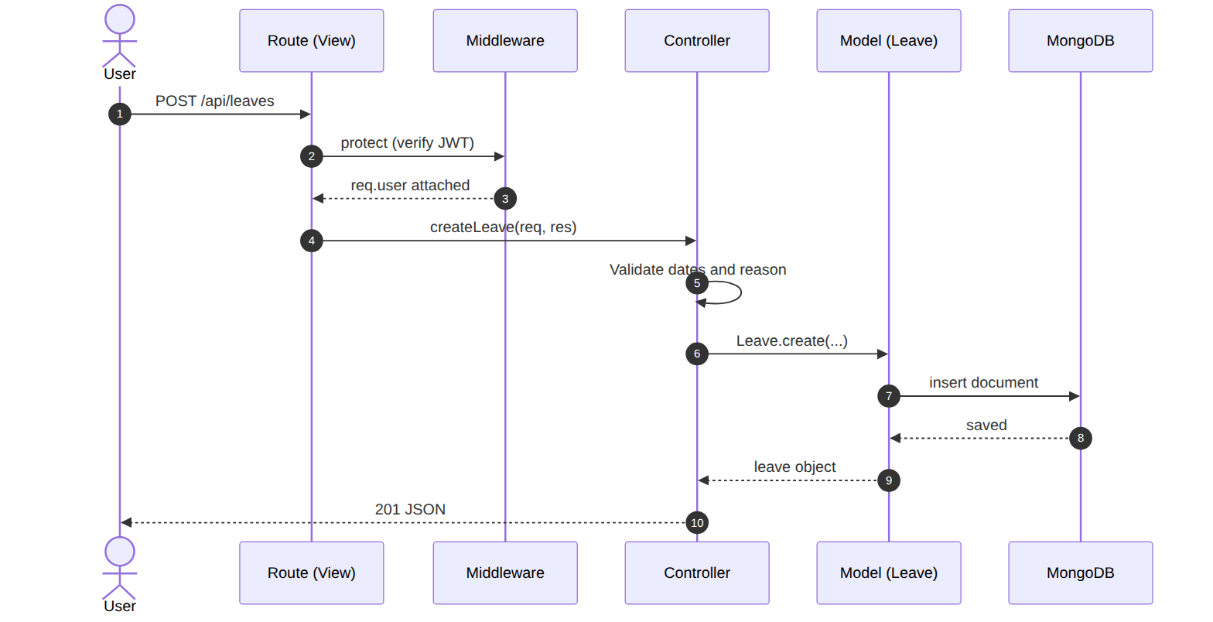

5. Request Flow Through MVC (Review Leave)
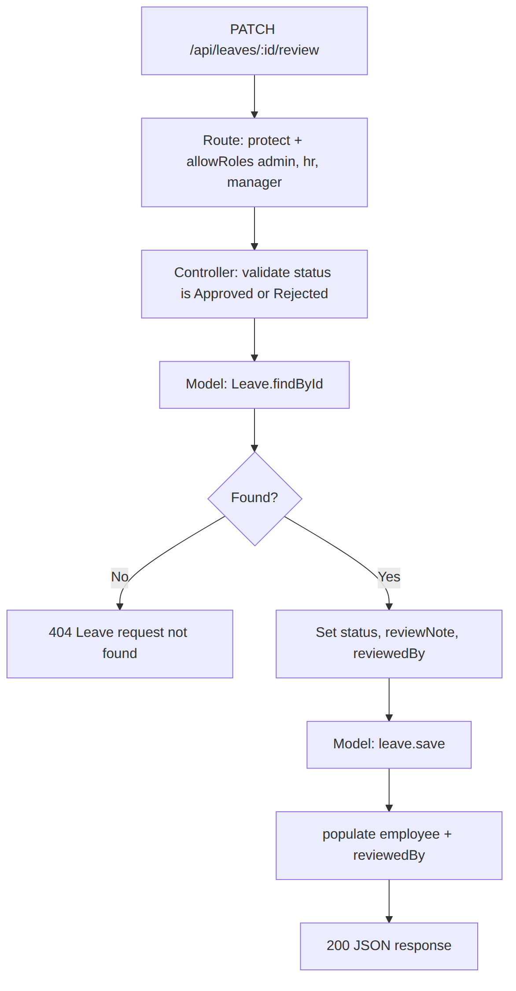

6. Advantages of Using MVC in This Project
Advantage | How it helps StaffSync
Separation of concerns | Each layer has a defined responsibility, improving readability and maintainability.
Scalability | New features are added by creating a new route, controller and model (for example a Payroll module).
Reusability | Controller and model logic can be reused across multiple parts of the application.
Testing | Each layer can be tested independently, especially controllers and models.
Collaboration-friendly | Several developers can work on different layers at once without conflicts.

7. Recommended Refactor: Extract Controllers
Before (handler inside the route file):
router.post('/', asyncHandler(async (req, res) => {
const { leaveType, startDate, endDate, reason } = req.body;
if (!startDate || !endDate || !reason)
return res.status(400).json({ message: 'Start date, end date and reason are required.' });
res.status(201).json(await Leave.create({ employee: req.user._id, leaveType, startDate, endDate, reason }));
}));
After:
// src/controllers/leaveController.js
import Leave from '../models/Leave.js';
export const createLeave = async (req, res) => {
const { leaveType, startDate, endDate, reason } = req.body;
if (!startDate || !endDate || !reason)
return res.status(400).json({ message: 'Start date, end date and reason are required.' });
const leave = await Leave.create({ employee: req.user._id, leaveType, startDate, endDate, reason });
res.status(201).json(leave);
};
// src/routes/leaveRoutes.js (the View / routing layer only)
import { Router } from 'express';
import { protect, allowRoles } from '../middleware/authMiddleware.js';
import { asyncHandler } from '../utils/asyncHandler.js';
import { createLeave, reviewLeave, listLeaves } from '../controllers/leaveController.js';
const router = Router();
router.use(protect);
router.get('/', asyncHandler(listLeaves));
router.post('/', asyncHandler(createLeave));
router.patch('/:id/review', allowRoles('admin', 'hr', 'manager'), asyncHandler(reviewLeave));
export default router;

8. Checklist: Adding a New Feature the MVC Way

